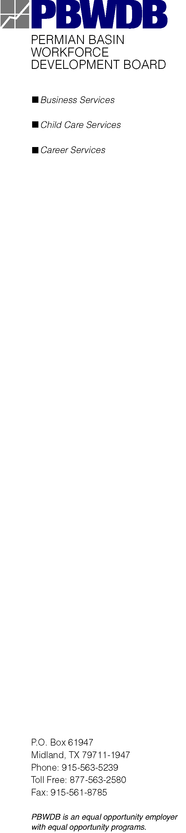

PERMIAN BASIN
WORKFORCE DEVELOPMENT BOARD

REQUEST FOR PROPOSALS
FOR
MANAGEMENT AND OPERATION OF
CHILD CARE SERVICES

PROCUREMENT TIMELINE AMEMDMENT
The following schedule delineates significant activities and dates regarding this procurement. The Proposal Due Date is changed to July 9, 2026. All other dates specified in the RFP document and listed below remain unchanged.

Release RFP | June 1, 2026
Deadline to Submit Letter of Intent | June 12, 2026
Final Date to Submit Written Questions Prior to Bidders Conference | June 14, 2026  3:00 pm Central Daylight Savings Time
Bidders Conference | June 16, 2026
Last Day for Written Questions | July 1, 2026  3:00 pm Central Daylight Savings Time
Proposal Due Date | July 9, 2026  4:00 pm Central Daylight Savings Time
Evaluation/Validation Period | July 9 – July 20, 2026
PBWDB Action on Recommended Proposal | August 10, 2026
Negotiation Period | August 15 – 31, 2026
Contract Effective Date | October 1, 2026

